HONEYCOMB

SPHERICAL FIGURE

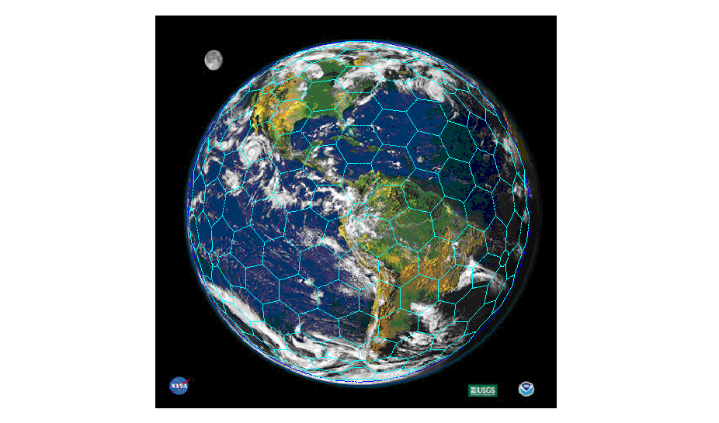

a.n.ditchfield

ALAMEDA PRINCESA IZABEL 2630 / 24 CURITIBA PR 80730-080
TEL(55 41) 339 1571 CEL(55 41) 9981 6620 alanneil@ig.com.br

PROFITABLE USES OF THE HONEYCOMB FIGURE
PATENT PI 9203881-6 BR 29/9/98; see: www.honeycomb.com.br
_______________________________________________________________________

This article describes an original approach to the manufacture and assembly of spherical objects. The Honeycomb is a geometrical figure with remarkable uniformity that divides the spherical surface into hexagonal cells, like those of a bee’s honeycomb. Such uniformity is useful when making objects with a spherical shape
The figure below illustrates the Honeycomb Figure superimposed on the Soccer Ball Figure, from which it is derived. Also shown are the four types of hexagon repeated throughout the sphere.

The Honeycomb Figure has:
- 750 arcs of equal length, 7º58’32”
- 540 nodes, of five types
- 260 hexagonal panels or four types

Nature offers no form better than a spherical surface to enclose a given volume. Shells have high mechanical strength. A thin eggshell of brittle material is strong because forces on its surface unfold into components that can be supported by the slender shell. Arc bridges and arc dams illustrate this and the spherical shell of a dome more so. In contrast, objects made with rectangular prismatic shapes introduce bending moments, shear forces and tension in addition to compression, requiring thick (expensive) members to maintain structural stability.
This is well known fact of mechanics but the challenge always has been the assembly of a spherical shell in sections, because it is hard to form plate according to two curvatures and difficult to join them. Such sub-division of a spherical surface, known as tessellation, is a demanding problem in geometry with solutions that do not lead to uniform components. One example is that of the globe, sectioned along planes of latitude and planes of longitudes, with a wide range of different components. Another example is the traditional standard for sport’s balls, with tessellation according to a spherical cube. Each of its six faces is further subdivided into spherical “rectangles” bounded by arcs of variable length. The current standard of soccer ball, known as the Geodesic Ball, has twelve black pentagons and twenty white hexagons with a gain in uniformity. The same pattern is seen on small balloons and spherical satellites used by NASA. The spherical cube is a basic figure often used for gas storage vessels. The economy of steel is so great that it pays to bend and join thick plates to a spherical shape.
In the middle of the 20th century Buckminster Fuller devised a space frame known as the Geodesic Dome. Its basic figure is the spherical icosahedron, sectioned with great circle arcs. Fuller expected its use as a universal cover, in millions, given the merits of economical use of materials and structural strength. Indeed, after the Kobe earthquake of 1996 a stream of technical articles attested the soundness of the lightweight domes under extreme conditions. Fuller’s hopes never materialised on the scale imagined, but with 300 thousand domes built it is one of the most successful designs ever contrived. It is often used for aesthetic reasons, such as the Epcot sphere in Disney-World, Florida. This space structure is economical in many situations, but requires cladding and waterproofing, taking the problem back to good tessellation of the surface of the sphere. In spite of the difficulty the Geodesic dome has found ubiquitous uses ranging from lightweight aluminium covers for petroleum tanks to tents and shelters for campers.
The Honeycomb Figure overcomes limitations of the Geodesic Spherical design with merits of uniformity that no other alternative figure possesses for the same degree of tessellation. It is the ideal figure to build domes with inflated panels of fluoropolymer sheets.
Patent rights were obtained for use of the Honeycomb Figure for the industrial applications shown in the following table.

OBJECTS OF PATENT PI 9203881-6 BR 29/09/98

- pressure vessels for gas storage | - high pressure reactors for the chemical industry
- communication satellites | - submarine petroleum tanks
- shelters for radar equipment | - bathyscaphs
- antennas | - buoys
- aviaries | - balloons
- concave mirrors | - inflatable structures
- dome covers for bulk storage | - concrete domes for nuclear reactors
- golf balls | - world-wide communications systems
- cartographic uses | - housing for ball bearing
- polycarbonate globes for lighting | - greenhouses
- igloo type military shelters | - structures for astronomy observatories

HONEYCOMB FIGURE INDUSTRIAL APPLICATIONS
________________________________________________________________________

There are a few detailed designs for Honeycomb applications but substantial engineering effort is needed to develop the full range of possible products. This endeavour is to be funded with risk capital and designs carry the assurance that nothing beats the spherical shape in economic use of materials and that no manner of sectioning the spherical surface surpasses the Honeycomb Figure in simplicity for manufacturing purposes.
In its origin, the Honeycomb Figure was studied for the design of a self-supported dome cover, but other possible applications are suggested. They are listed to illustrate the versatility of a geometrical figure that leads to high uniformity of components, precious for manufacturing purposes.

DOME COVERS FOR GRAIN STOCKPILES.

A comparison was made of alternatives for grain storage, matching a conventional steel silo with a Honeycomb dome cover for a grain pile, plus their foundations. A conventional steel silo to store 1200 m³ of grain would cost US$35,000 versus US$15,000 for a Honeycomb dome cover over a grain pile.

DOME COVERS FOR PETROLEUM TANKS

More than 8 thousand aluminium dome covers have been made in the U.S. to replace the traditional steel conic tank -tops. For a tank with a diameter of 20 m the aluminium dome weighs 4 tons, versus 21 tons for the steel cone. Also, aluminium is free from corrosion and does not require welding, qualities that add to safety in storage of flammable materials.

PRESSURE VESSELS

These may be spheres for gas storage or high-pressure reactors for the chemical industry. It is now usual practice to form hot pressed steel plate with sections derived from the spherical cube, with a dozen 70º 31’44”arcs as edges. The predictable gains with the Honeycomb geometry would be those inherent to the small curvature of smaller sections. They would be more numerous but their joining would be simplified since there are 750 joints of equal length.

COMMUNICATIONS SATELLITES

These can be made with hexagonal aluminium panels made by explosion forming, a technique used by the aircraft industry. In it a mould is made with the required curved surface; an aluminium sheet is stretched over the mould and fixed along the rim; the mould is placed in a chamber and submitted to the blast of a controlled explosion that exerts uniform pressure in all directions.
The shell thus made has precise dimensions and none of the residual stresses typical of presswork. Aluminium is the ideal metal for explosion forming.

BEARINGS
For shafts of petroleum drills, harbour cranes, tunnelling equipment, and similar equipment. These have large shafts subject to both longitudinal and radial forces. Chromium steel ball bearings are tangent among themselves and with two concentric spherical shells. The balls would be arranged in ruts in the housing, with Honeycomb geometry. The case itself would be a spherical zone (the sphere minus north and south caps).

CONCAVE MIRRORS

These would be formed with explosion formed aluminium hexagonal panels of high precision, with a silver finish. Such mirrors are used for industrial processes that require high temperatures, generated by focusing sunlight.

BALLOONS AND INFLATABLE STRUCTURES

These are applications in which the uniformity of 750 joints of equal length facilitates the joining of sections.

AVIARIES AND ORNAMENTAL STRUCTURES

These are special frames that can be built with round aluminium tubes, with four types of joints.

PUBLIC LIGHTING SPHERES

Made with transparent polycarbonate, such sphere can be assembled with 260 hexagonal panels of only four types. Panels are produced by the rotational moulding process.

TRANSPARENT DOMES

Fluorocarbon polymer film covers for greenhouses and polycarbonate domes for architectural applications.

POSITION REFERENCING SYSTEMS

The Honeycomb Figure is of general interest to position referencing systems on a spherical surface, as needed for charting, GPS systems, guidance of missiles, and control of movements of robots and of helicopters. New international standards for map projections are needed to allow global measurements in a manner suitable for digital data interchange and comparison. The traditional meridians and parallels introduce distortions that hinder traffic of images in a worldwide communications system.
The globe on the cover page illustrates the scope of an idea presented at the international conference of global grids called by the University of California – Santa Barbara, in March 2000 to define the needed new standards.

ILLUSTRATIONS OF USES OF HONEYCOMB FIGURE
DOME COVER FOR BULK STORAGE  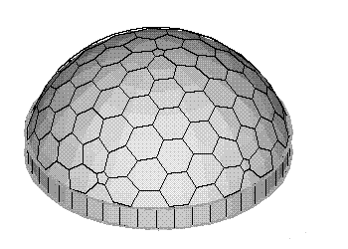 | PETROLEUM TANK COVER  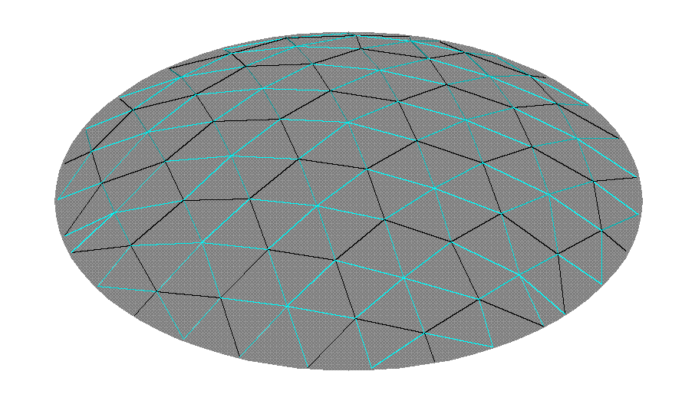
SPACE FRAME  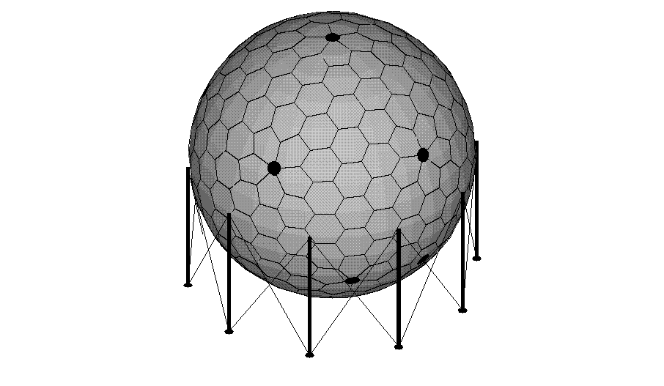 | GAS STORAGE VESSEL
GOLF BALL  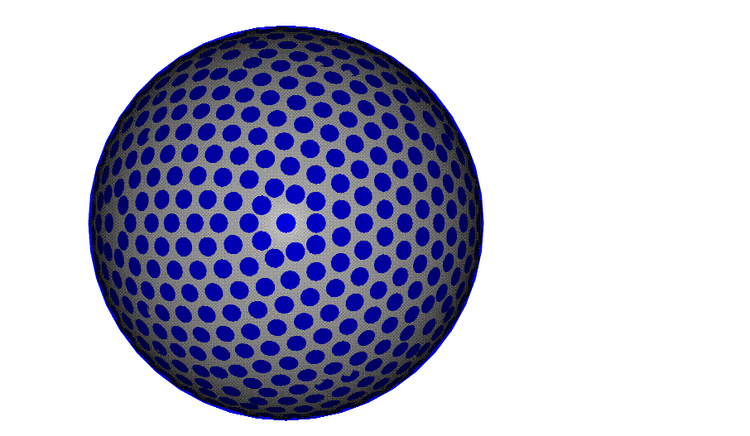 | CASE FOR BALL BEARINGS  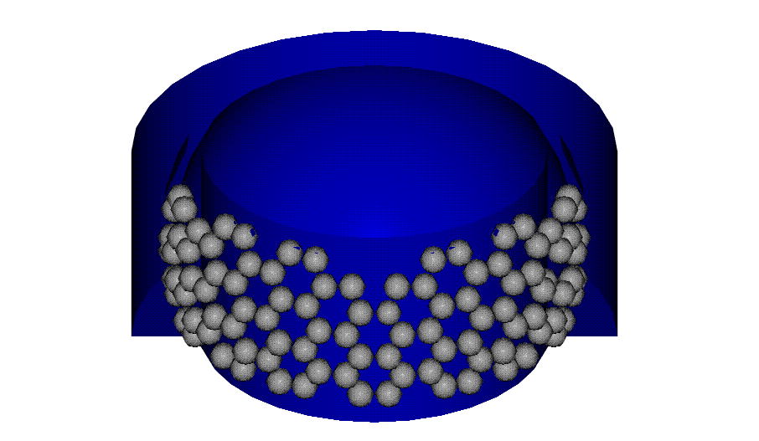
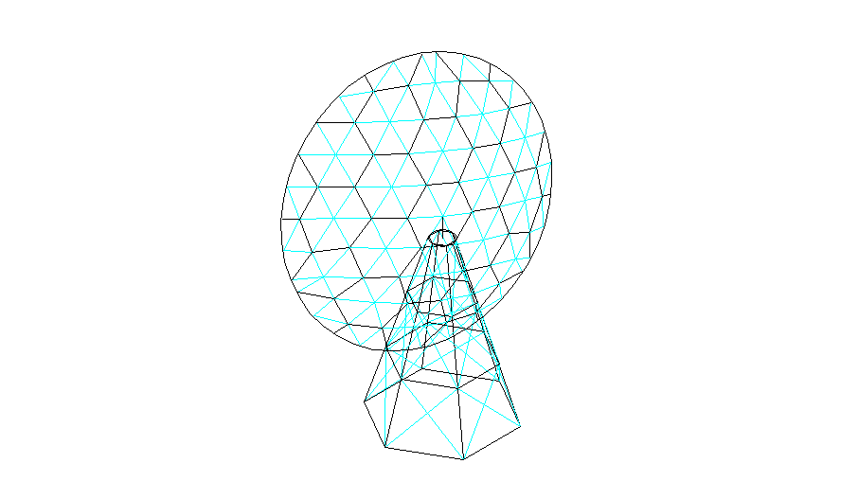

GEOMETRY OF THE HONEYCOMB FIGURE

The soccer ball figure has 60 vertices, 20 regular hexagons and 12 regular pentagons, all with 90 equal edges, the 23º16’53” .arc. The Honeycomb figure is derived from it in a procedure that inscribes in these hexagons and pentagons 750 arcs with equal length, 7º58’32”, as edges of four types of spherical hexagons, and 12 pentagons or circles with radius 2º53’21”.
SOCCER BALL HONEYCOMB
basic figure derived figure

Given the uniformity of the tessellation, the Honeycomb figure has a repetitive pattern four types of hexagon, a,b,c,d, that enclose the entire surface of a sphere with 260 hexagons and 12 pentagons (or circular caps).

GEOMETRICAL DEFINITION OF THE HONEYCOMB FIGURE

REPETITIVE PATTERN IN HONEYCOMB FIGURE
BASIC CONFIGURATION OF VERTICES IN THE HONEYCOMB FIGURE

The Honeycomb is derived from the soccer ball figure in a mathematical procedure that inserts arcs in its hexagons and pentagons to achieve simplicity in their subdivision. The Honeycomb figure is unique in that it has 750 arcs of equal length 7º975567, reached with a configuration of vertices 2,7,12,13,22,23,32,37,52 repeated sixty times over the surface of the sphere. The arcs and angles of this configuration are shown in the diagram below: They allow the spherical coordinates to be computed for these nine points, referred to the base point 567, and then computed for all 540 points of the Honeycomb figure by rotation and transformation.

CONSISTENCY CHECK OF THE HONEYCOMB FIGURE

The sum of spherical excesses of all polygons on the surface of a sphere is equal to 4π
The Honeycomb has the following components:
number of faces spherical excess
number each total
(20 × (1 hexagon type a ) 20 0.050622 1.012431
(20) × (6 hexagons type b ) 120 0.050625 6.075002
(30) × (2 hexagons type c ) 60 0.050053 3.003153
(20) × (3 hexagons type d ) 60 0.040054 2.403214
260 hexagons
(12vertices) × (1 pentagon/vertex) 12 pentagons 0.006048 0.072571
total faces 272 faces 12.566371 = 4π

number of edges
Long_arcs with 7º975567,
edges of hexagons
20 × 33 long_arcs 660 long_arcs
30 × 3 long_arcs 90 long_arcs
Short_arcs with 3º395451,
edges of pentagons inscribed in caps
(12vertices) × (5 short_arcs/vertex) 60 short_arcs
total edges 810 edges
number of vertices
20 × 18 vertices + 30 × 6 vertices = 540 vertices

The number of components meets the requirement [# edges] = [# vertices] + [# faces-2]
[810] = [540] + [272 - 2]

Spherical coordinates and Cartesian coordinates for all 540 vertices were computed with a FORTRAN program and confirmed with an MS Excel spreadsheet. A table of incidences was made showing how arcs join pairs of vertices, and a final check was made by computing distances between vertices: arc between two points of given spherical co-ordinates: P₁ (ϕ₁,λ₁) and P₂(ϕ₂,λ₂): $d=a\text{cos}\left(\text{cos}j_{1}\text{.}\text{cos}j_{2}+\text{sin}j_{1}\text{.}\text{sin}j_{2}\text{.}\text{cos}(λ_{1}−λ_{2})\right)$

